Business Summary

**Pre-acquisition P&L:**

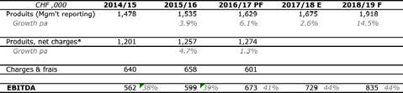

For 2018-19, new contracts signed are conservatively expected to deliver an incremental CHF200,000 in revenue. Improved controls on cash could drive an additional CHF40,000 in EBITDA.

**Fleet:**

* Vehicles are wholly owned by the companies without any financing or leasing outstanding
  + Estimated current market value CHF450,000
* 8 x minivans (7-8 pax), 4 x minibuses (13-16 pax), 1 x SUV, 1 x luggage trailer
* Average TPP vehicle age = 3 years

**Lease agreements:** Sales office in resort (18k pa)

**Staff:** Staff are seasonal except where noted below.

MD (annual 80% FTE), Office assistant x 1, Drivers x 16

**Clients under contract**

* Total revenue 1.675m
  + Under long-term contracts: 350k
  + B2C direct: 630k
* The remaining 825k is with accommodation providers on an annual contract, the majority of whom we have been working with for 3-5yrs

**Top client revenue**



**Contracts overview:**

* Exclusivity for 5yrs
* Guaranteed pricing
* Commission rates – typically 10-25%
* Strictly confidential

**Cost of replacing MD**

* MD current salary: CHF70k
* Would replace with 2 managers (to begin with) on CHF 75k-85k each
  + The work is seasonal: full time 4 months a year, 8 months at 25% of 1 person
* Net additional cost: CHF95k